Names: __________________________________________________________________________
Fill in the sentences below to show what habitat each animal belongs in!
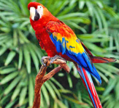 | The parrot belongs in the ________________________ habitat because _________________________________________________________________.
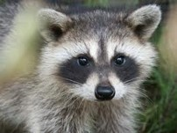 | The raccoon belongs in the ________________________ habitat because _________________________________________________________________.
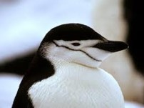 | The penguin belongs in the ________________________ habitat because _________________________________________________________________.
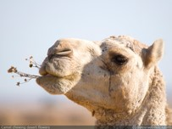 | The camel belongs in the ________________________ habitat because _________________________________________________________________.
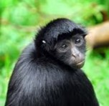 | The monkey belongs in the ________________________ habitat because _________________________________________________________________.
 | The dolphin belongs in the ________________________ habitat because _________________________________________________________________.
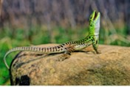 | The lizard belongs in the ________________________ habitat because _________________________________________________________________.
 | The polar bear belongs in the ________________________ habitat because _________________________________________________________________.
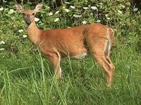 | The deer belongs in the ________________________ habitat because _________________________________________________________________.
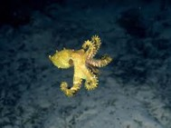 | The octopus belongs in the ________________________ habitat because _________________________________________________________________.

